Tag Heuer SmartWatch!

Want an expensive smartwatch, but hate Apple? Tag Heuer comes at your rescue!



All the people, who want a smartwatch, who aren’t pleased by the Google wear and hate Apple, don’t need to worry now. Because the Swiss company, Tag Heuer is all set to fire up the smartwatch market with it’s all Swiss Smartwatch! We are enthusiastic, but can already hear our bank balances cry out in fear. If you want to put this masterpiece on your wrist, then you are going to have to part with a hefty $1400! Although it’s not quite as wallet-trembling as the Gold Apple watch edition, which goes for ludicrous $17,000, this already makes the other versions of Apple Watch seam cheap in comparison.

Tag Heuer also revealed that the watch will be available in the first week of November. Although it is an undeniably expensive, you will be getting your gorgeous piece of the kit for your money, with Tag Heuer’s legendary designers crafting, it could be one of the most desirable smartwatches in the world! Tag Heuer hasn’t already revealed much of the details, but we know that the battery backup is going to be spectacular! Tag Heuer smartwatch will have a 40 hour battery life, putting Apple Watch and almost all the Android Wear devices to shame!

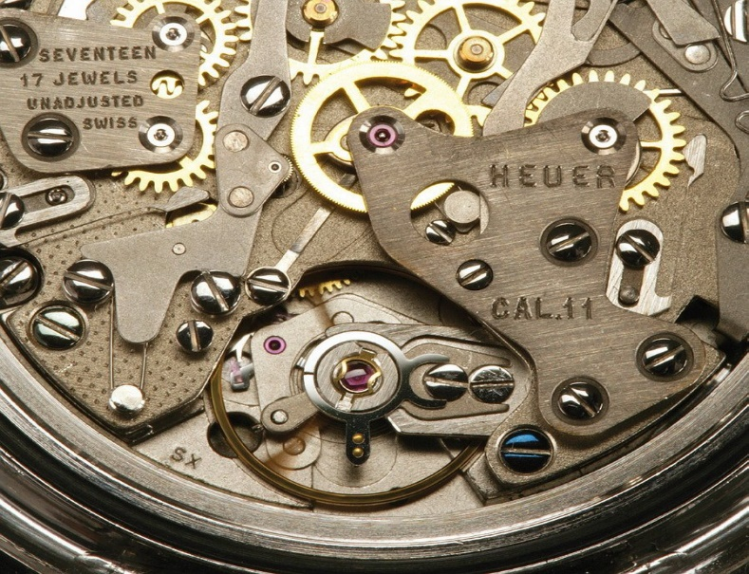

Tag Heuer, with all its marketing power is making sure that everyone knows that its watch is purely Swiss made, with more than 50% of the parts manufactured in Switzerland – a country which has impeccable credentials when it comes to Watch Manufacturing.

So, if you got a Hefty amount in your bank balance and want a royal makeover of your wrist, then grid your accounts for November and own a Swiss Smartwatch, crafted to perfection!